Report for the lab 3 unit 2.

Task 01: Export Geo Location Reference

Creating the user SB_MbackUp on the ts_sa_fact_sales_data_01 tablespace:

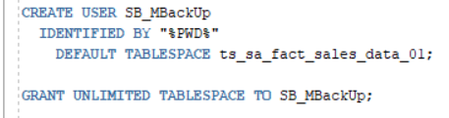

First of all the table geo_data_structure is created as left join with tables t_geo_objects with t_geo_types, t_geo_object_links, lc_cntr_group_systems, lc_cntr_groups, lc_cntr_sub_groups, lc_countries, lc_geo_regions, lc_geo_parts, lc_geo_systems joined by id.

It helps us to clarify which rows are roots (geo_id equals to parent_geo_id):

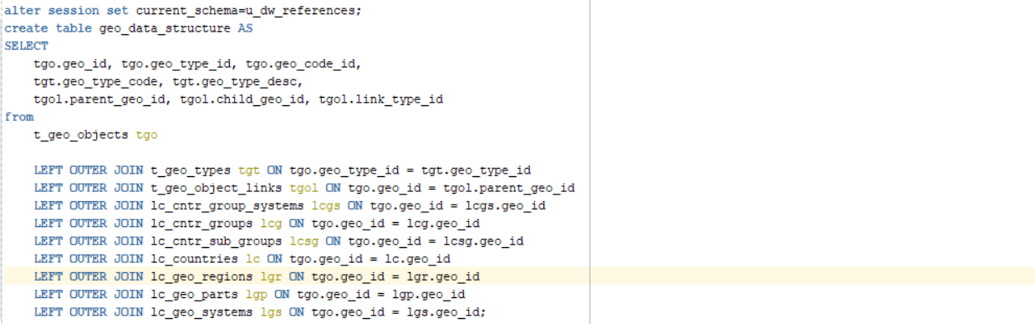

As the result we obtained table with data about the own id, parent id, child id:

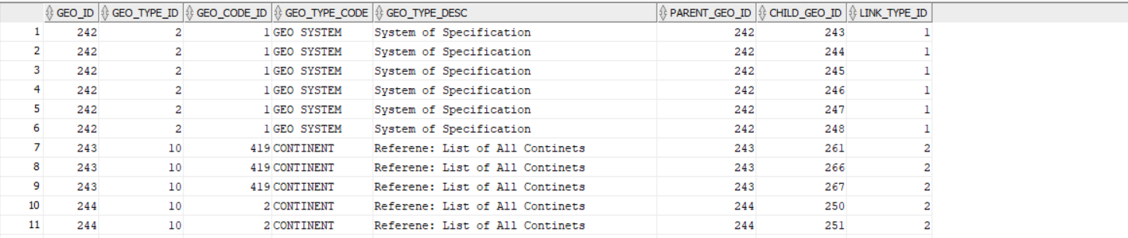

As we can see first 6 rows with geo type ‘geo system’ have the same id as parents. So it means that there are roots.

Also from this data two hierarchies are built:

Geo system-> continent-> region-> country (geographical)

Group system-> country group-> country sub group-> country (economical)

We need to use the first one (lets call it t_geo_hierarchy).

The lowest hierarchy level is t_geo_links left joined with t_geo_types on parent_geo_id and child_geo_id and geo_id:

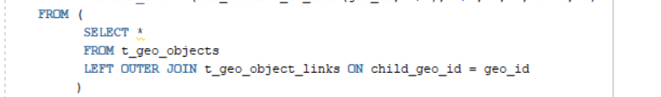

As the result we obtained:

